# javaScriptCodeStep

**Objective:**

It is used to execute any custom external javascript code.

**Attributes:**

|  |  |
| --- | --- |
| **Attributes** | **Description** |
| src | To enter the src code |
| function_name | To enter the function name |
| returnOutputVariable | Used to store the response of the request |
| dynamicParams | To enter the dynamic params |
| inline | It is boolean if is true then execute src code directly, is false then go to src location |

**Sample config.json:**

{

"workflows": [

{

"name": "code-java-script",

"id": 200,

"trigger": "rest",

"expression": "code-java",

"method": "GET",

"steps": [

{

"type": "start",

"id": 1,

"next": {

"start": "start"

}

},

{

"src": "javascriptcode.js",

"inline": "false",

"function_name": "myFunction",

"returnOutputVariable": "true",

"dynamicParams": "{5,9}",

"type": "code-js",

"id": "start",

"next": {

"success": "code-js-success",

"failure": "hangup"

}

},

{

"variable_name": "code-js-output",

"http_response_code": "200",

"response_content_type": "text/html",

"value_type": "hb",

"type": "send",

"id": "code-js-success",

"next": {

"success": "hangup",

"failure": "hangup"

}

}

]

}

],

"filters": [],

"server": {},

"plugins": []

}

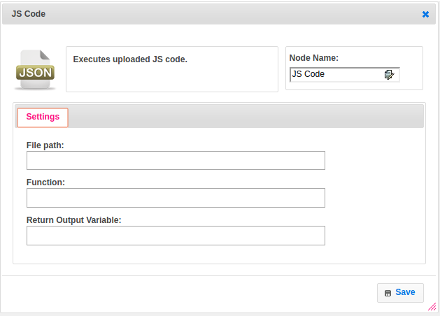

**Executor Description:**

In executor class if inline is true execute code directly with src, the inline code should return map object into which you can insert new keys and remove the existing keys. If returned value is not map then set that value to Map, where the key name is the function_name. Function should return the map object so that it will be usable in further steps.